**HTML INTRODUCTION**

The **HTML** stands for  **HyperText Markup Language.** Itis the standard markup language for documents designed to be displayed in a web browser. You can make your own website using HTML. It defines the meaning and structure of web content. It can be assisted by technologies such as Cascading Style Sheets (CSS) and scripting languages such as JavaScript to describe a web page's presentation or appearance and functionality.

The term "hypertext" refers to links that connect online pages inside a single website or between websites. Links are an important part of the Internet. HTML annotates text, pictures, and other content for display in a Web browser using "markup." Tags, which are written in angle brackets, separate HTML elements. Tags like <img /> and <input /> insert content into the page immediately. Other tags, such as <p>, surround and offer information about document text, and may comprise sub-elements of other tags. An element's name inside a tag is case insensitive. It can be written in capital, lowercase, or a combination of both. The <title> tag, for example, can be written as <TITLE>, <Title>, or any other variation. However, it is conventional and advised to write tags in lowercase.

**Importance in Web development:**

1. **Structure and Semantics**: HTML provides the structure and semantics for web content. Using proper HTML elements, like headings, lists, and semantic tags, makes web content more understandable.

2. **Cross-Browser Compatibility**:- HTML is supported by all major web browsers, ensuring that web pages look and function consistently across different platforms and devices.

3. **Foundation for Web Design**:- HTML works in conjunction with Cascading Style Sheets (CSS) to control the presentation and layout of web content. CSS defines how HTML elements are displayed, allowing for creative and responsive web design.

4. **Integration with Other Technologies**:- HTML can be combined with scripting languages like JavaScript to create dynamic and interactive web pages. JavaScript, for instance, can manipulate HTML elements in real time

5. **SEO Optimization**:-Search engines use HTML markup to understand the content of a web page. Using appropriate HTML tags and attributes can improve a site's search engine ranking.

6. **Mobile Compatibility**:-HTML5, the latest version of HTML, includes features and APIs that support mobile web development. This is essential in an era where mobile browsing is prevalent.

7. **Rich Media Integration**:- HTML5 introduced new elements for embedding multimedia content, such as audio and video, without the need for third-party plugins like Flash.

**Discuss the evolution of HTML and its versions**

HTML 1.0 (1993): The first version for basic text-based web pages.

HTML 2.0 (1995): Added forms, tables, and improved structure.

HTML 3.2 (1997): Introduced frames and basic styles.

HTML 4.0 (1997/1998): Brought more elements, scripting, and better styling.

HTML 4.01 (1999): Minor revision with internationalization.

XHTML 1.0 (2000): Combined HTML with XML for stricter rules.

HTML5 (2014): Revolutionized with multimedia, APIs, and semantics.

* HTML5 marked a significant shift in web development. It introduced numerous new elements, APIs, and features, including <canvas>, <video>, and <audio> elements.
* HTML5 also introduced semantic elements like <header>, <nav>, <article>, and <footer>, improving web document structure and search engine optimization.

HTML 5.1 (2016): Added new elements and features.

HTML 5.2 (2017): Minor updates and refinements.

HTML 5.3 (2020): Introduced new features and improvements.

HTML 5.4 (proposed): Ongoing development for the modern web.

**Base Tags**

As Web developers, we all have to use HTML as our basic language for building the structure of the whole website. More specifically "HTML Tags" play a very vital role in writing efficient HTML programs.

Why HTML tags?

Ok... Before starting with "What?" let's understand "Why?"

Each markup language has its own set of rules for creating, Defining, modifying, displaying & and formatting the block of content on the editor or website. In HTML (Hypertext Markup Language) uses elements & and tags for proper presentation of content as per the requirement of admin & user.

What are HTML tags?

HTML tags are used for defining the blocks of text and assigning formatting. HTML tags are special keyword which is used to wrap the content & apply the rule of specific tag on the whole wrapped content.

We wrap the block of content using angle brackets: <tag keyword>. Majorly (Not all) tag comes in a pair of opening & closing tag. The closing tag is the same as an opening tag with the addition of a forward slash.

Example: <tag> ... Block of content... </tag>

Some tags don't have any closing tags. <img> tag is one of them as we don't need to define an opening and closing to display an image, just a location of where the image can be found.

Example: <img src="path_of_image">

**List of common HTML tags:**

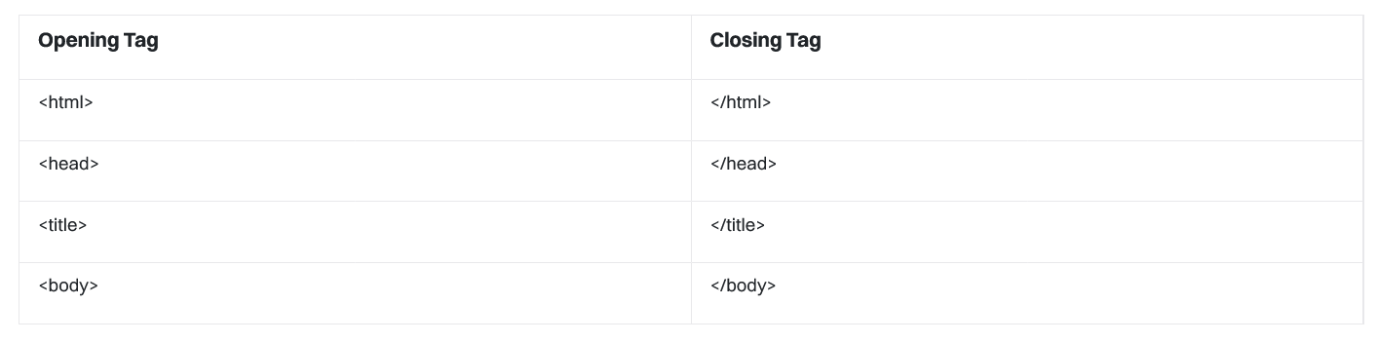

**Container tags:**

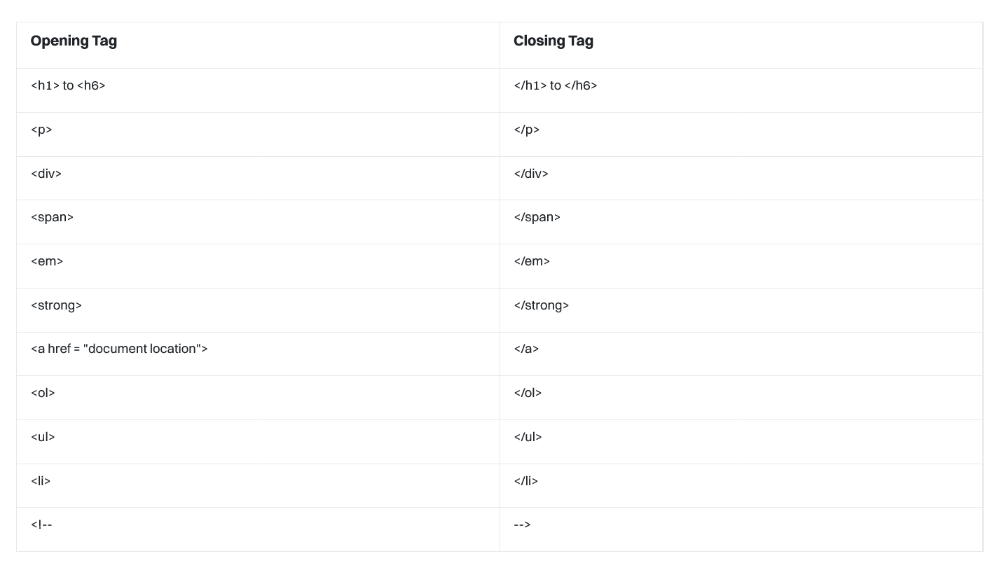

**Semantic HTML tags:**

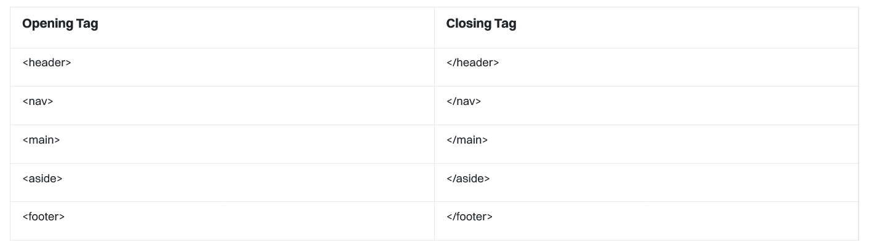

**Empty (Non-Container) Tags:**

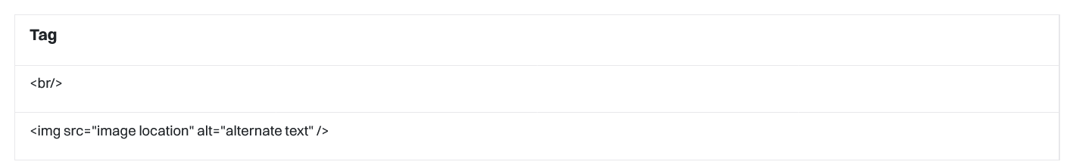

**Tags for Table**

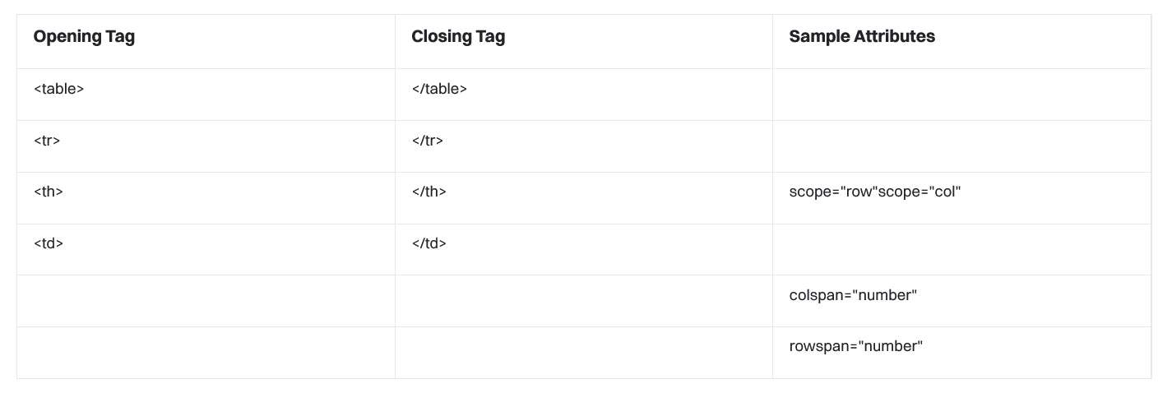

**Basic HTML syntax:-**

**<!DOCTYPE html>**

**<html>**

**<head>**

**<title>Lets learn about Title Tag</title>**

**</head>**

**<body>**

**<h1>See above in the Page title bar</h1>**

**</body>**

**</html>**

**<!DOCTYPE HTML>**

The <!DOCTYPE> declaration assists the browser inappropriately interpreting the document by specifying the version of HTML being used. <!DOCTYPE html> in the example above denotes the usage of HTML5.

**<Head>**

HTML's <head> element is an important component of the document structure; it usually holds links to other resources, metadata, and other important information for the web page that the user cannot see immediately.

**<html>**

A key component of HTML (Hypertext Markup Language) is the <html> tag, which acts as the root or container for a whole web page. It is a crucial component of the document's structure and indicates the start and finish of the HTML text.

**Title**

As a Web Developer, we all have to use HTML as our basic language for building the structure of the whole website. More specifically "HTML Tags" play a very vital role in writing efficient HTML programs. In this article, we will be learning about "Title Tag".

**What is Title Tag?**

Title tag element is used to specify the Title of the Webpage.

Content inside <title> tag should consist only text & it is displayed on Browser Title Page Tab.

**Note:**The <title> tag is required in HTML documents.

The contents of a page title is very important for search engine optimization (SEO)! The page title is used by search engine algorithms to decide the order when listing pages in search results.

Here are some tips for creating good titles:

* Go for a longer, descriptive title (avoid one- or two-word titles).
* Search engines will display about 50-60 characters of the title, so try not to have titles longer than that.
* Do not use just a list of words as the title (this may reduce the page's position in search results).

**Body**

What is <body> tag?

The <body> tag defines the document's/ Webpage body. The body tag contains starting & ending tag.

The <body> element contains all the contents of an HTML document, such as headings, paragraphs, images, hyperlinks, tables, lists, etc.

Exercise:-

1. Writing Your First HTML Code.

2. Create a webpage of your choice which need to be include:- title, heading, paragraph.

3.Program to see difference between paragraphs & normal text with line break

4.Write an HTML program to display hello world.

5.Write a program to create a webpage to print your city name in red color.

6.Write a program to print a paragraph with different font and color.

Adding Images:-

As a Web Developer, Building beautiful & Self explanatory website is really necessary. Specially these day adding media on our website is really necessary. There are lots of media types, audio, video, etc

Q:- What is <img> tag?

The HTML <img> tag is used integrate image file on a web page & using its attributes we specify the path of image file.

Note: Using <img> tag we are just linking the images to webpage.

* Important attributes used in <img> tag:
* src attribute: It is used to specify path of image.
* alt attribute: It is used to specify an alternate text for the image.

Syntax :- <img src="Path_to_image/url alt ="alternate_text">

In the above example, we have linked an image into our website using <img> tag & specified it path using src attribute. If due to a path error, <img> tag is unable to detect the image on specified path then it will flash the content written in alt attribute.

Adding Audio:-

Q:- What is <audio> tag?

The HTML <audio> tag is used integrate audio file on a web page & using its attributes we can control the embed audio file. The “audio” tag is an inline element that is used to embed sound files into a web page.

We use multiple attributes of "audio" tag:

* Controls: It is used to specify what controls to display with the audio player.
* Autoplay: It is used to specify that the audio file will play immediately after it loads controls
* Loop: It is used to specify that the audio file should continuously repeat.
* src: It is used to specify the URL of the audio file
* muted: It is used to specify that the audio file should be muted.

Syntax:-

<audio controls>

<source src="./audio/whistle-vibes-172471.mp3" type="audio/mpeg">

Does not support audio .

</audio>

The controls attribute adds audio controls, like play, pause, and volume.

The <source> element allows you to specify alternative audio files which the browser may choose from. The browser will use the first recognized format.

The text between the <audio> and </audio> tags will only be displayed in browsers that do not support the <audio> element.

Adding video:-

Q:- What is <video> tag?

The HTML <video> tag is used to display a video on the website & using its attributes we can control the embed video file.

We use multiple attributes in "video" tag:

* Autoplay: It instructs our website to start playing video as soon as the video is downloaded.
* Loop: It instructs our website to keep playing video continuously in loop.
* Height: It is used to set the height of the video in CSS pixels.
* Width: It is used to set the width of the video in CSS pixels.
* Controls: It is used to pass control related commands to video. Like: play, pause, volume, etc.
* Muted: It commands the website to mute the audio of video.
* src: It is used to specify the URL of the video file.
* Poster: It loads an image to preview before the loading of the video.

Example of implementation of <video> tag:

<h1>Video Example</h1>

<video width="640" height="360" controls>

<source src="video.mp4" type="video/mp4">

<source src="video.webm" type="video/webm">

Your browser does not support the video tag.

</video>

Iframe:-

Q:- What is iframe?

An HTML iframe is used to display a web page/video/image/document within a web page.

The HTML <iframe> tag specifies an inline frame.

Tip: It is a good practice to always include a title attribute for the <iframe>. This is used by screen readers to read out what the content of the iframe is.

Syntax:-

<iframe src="URL_to_external_content" width="width" height="height" frameborder="0">

</iframe>

src: This attribute specifies the URL (web address) of the content you want to embed.

width: This attribute sets the width.

height: This attribute sets the height.

frameborder: This attribute determines whether or not to display a border around the iframe. Setting it to 0 means no border, and setting it to 1 displays the border.

Attributes:-

As a Web Developer, we all have to use HTML as our basic language for building the structure of the whole website. More specifically "HTML Tags" play very vital role in writing efficient HTML program. In most of the case we need to use attributes to specify the working of any specific tag.

Q:- What are HTML Attributes?

Definition: HTML attributes are used to specify extra information or command to HTML elements. Every HTML tag/elements can have attributes for defining the behavior of that element.

We should always apply attributes with start tag.

Attributes can be only applied in name & value pair.

Attributes are case sensitive.

Mainly it is written in lowercase.

We can apply multiple attributes in single HTML element.

Src:- It is simply use to specify the path to image file or its URL. Using source attribute we can link the image into our webpage.

Alt:-Attributes are simply used inside tag for providing additional information about the element or tag.

The HTML "alt attribute" is used to provide an alternate text content that will be used to display the value of alt attribute if the primary attribute i.e., the <img> tag, fails to display the value assigned to it.

Alt attribute is used in supported tags for providing alternate content.

Href:-

Q:-What is "href" attribute?

The break up of the "href" attribute is "Hypertext Reference". So the full form itself defines that "href is used to for taking reference from Hypertext (text linking to another section of text)".

Definition: "href" attribute is used inside limited HTML tag for specifying the URL of the page that link goes to.

"href" attributes can be used in following elements:

<a>

<link>

1. <a> tag with href attribute:

In Anchor / <a> tag, href attribute is used to specify the URL of the page that link goes to.

Syntax:-

<a href="....URL">Visit W3Schools.com!</a>

2. <link> tag with href attribute:

Example: We use <link> tag in header file for specifying the location of CSS file for styling of HTML elements.

Syntax:-

<link rel="stylesheet" href="styles.css">

Assignment 1:

Task: Create a basic HTML webpage containing an image.

Requirements:

Use the <img> tag to display an image on the webpage.

Find an image online or use your own image.

Set the src attribute to the URL or file path of the image.

Provide an alt attribute with a descriptive text for accessibility.

Assignment 2:

Task: Create a gallery of images.

Requirements:

Create a webpage displaying multiple images in the form of a gallery.

Use the <img> tag for each image.

Arrange the images in a visually appealing manner.

Include a caption or description below each image using appropriate HTML elements.

Assignment 3:

Task: Create a basic HTML webpage with an audio player.

Requirements:

Use the <audio> tag to embed an audio file on the webpage.

Find an audio file online or use your own audio file.

Set the src attribute to the URL or file path of the audio file.

Include audio controls for play, pause, and volume adjustment.

Assignment 4:

Task: Create a Webpage with Embedded YouTube Videos.

Requirements:

Create an HTML document containing text content.

Embed at least two YouTube videos using <iframe> tags. Pick videos of your choice.

Set the appropriate video URLs in the src attribute and adjust the width and height for each video.